**Software Requirement Specification**

**Temperature Conversion Calculator**

**Purpose**: To ease calculations and to check temperature as per user choice.

**Overall Description**: The calculator is designed to perform functions like Fahrenheit to Celsius, Celsius to Fahrenheit, Kelvin to Celsius, Celsius to Kelvin, Fahrenheit to Kelvin, Kelvin to Fahrenheit.

**Feasibility Study:**

**What:** Calculator to convert among temperature units.

**Why:** To perform calculation and change forms of temperature so as to ease it for user.

**Where:** Mainly used in hospitals and weather forecasting.

**When:** This application is used when the user wants to convert temperature from one form to another

**How:** Based on the user choice the following formulas are executed:

* Celsius to Fahrenheit: fah = (cel*9/5)+32
* Celsius to Kelvin: kel = (cel + 273.15)
* Fahrenheit to Celsius: cel = ((fah - 32)*5)/9
* Fahrenheit to Kelvin: kel = ((fah - 32)*5)/9 +273.15
* Kelvin to Celsius: cel = (kel - 273.15)
* Kelvin to Fahrenheit: fah = ((kel - 273.15)*9)/5+32

**Specific Requirements:**

1. High level Requirements:
   * + - Software to code application
       - Data types
       - Complied by gcc C Compiler
       - Written in C
2. Low level Requirements:

* Need a system that supports gcc Compiler.

**UML Diagram:**

1. **Structural Diagram:**

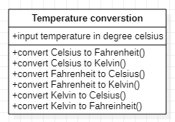

Fig: Class Diagram

1. **Behavioural Diagram:** 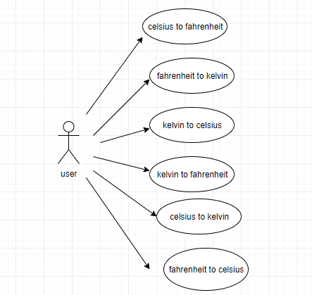

Fig: Use Case Diagram

SWOT Analysis:

|  |  |
| --- | --- |
| Strength  It helps to reduce calculation and get temperature in various formats very easily.  It has an accuracy of up to two floating points. | Weakness  We don’t have an attractive user interface. |
| Opportunity  We can make good GUI for temperature conversion application.  Customization can be done based on region. | Threats  The conversion could make no sense if the input entered is out of limit or threshold. |